Da Boot
Bug submission and tracking software
By: Max Ooi Wei Xiang

Table of Contents
Context 1
Goals and Non-Goals 1
Proposed Technical Architecture 1
User-Interface 2
Database Design 6
Milestones and Timeline 6

Context
The aim of this project is to provide an platform for developers and contributors to track bug fixes over time. Developers can subsequently send links to software users to submit bugs directly.

Goals and Non-Goals
The goals of this project are:
- User Authentication and Authorization, using both username+password and Oauth method
- Unauthenticated users can submit bugs only and register/sign in to be a tester
- Authenticated users can search for users and be a tester without approval
- Different roles for each project, with each role being able to perform the previous roles’ tasks:
  - Tester – Submit and view past bug tickets, request for promotion to developer
  - Developer – Close, edit, assign and comment on bug tickets, request for lead switch
  - Lead – Create projects, approve role elevation and lead switch, promote and demote all users within the project
- Each ticket has submission, assignment and plan-closeout and closeout date, color coded based on urgency.
- Demotion-lock, if users are assigned tickets

The non-goals of the project, which could be of interest in the future, are
- Progress checking and milestones for each ticket
- Email alerting

Proposed Technical Architecture
The proposed tech stack used for this project is ASP.NET Core with C#, on an MVC framework. Back-end database is provided by MySQL running on AWS RDS.

User-Interface
Main dashboard
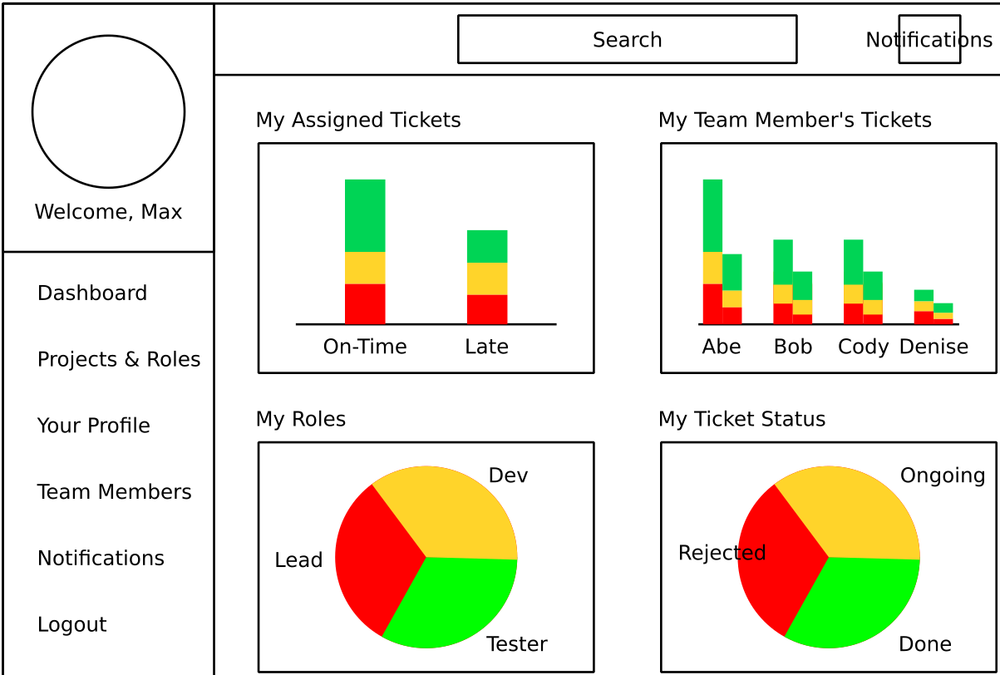

Projects and Roles
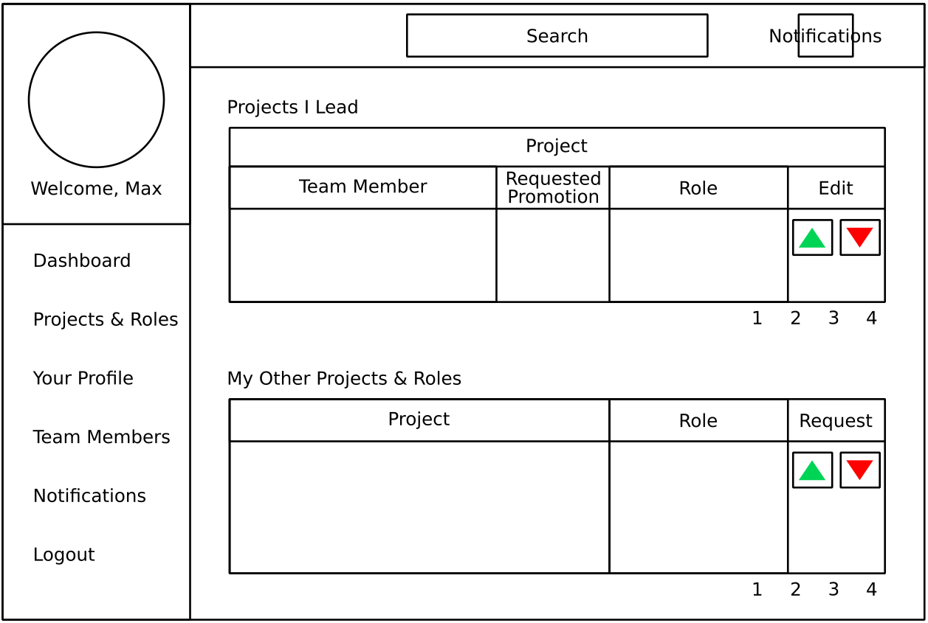

User profile
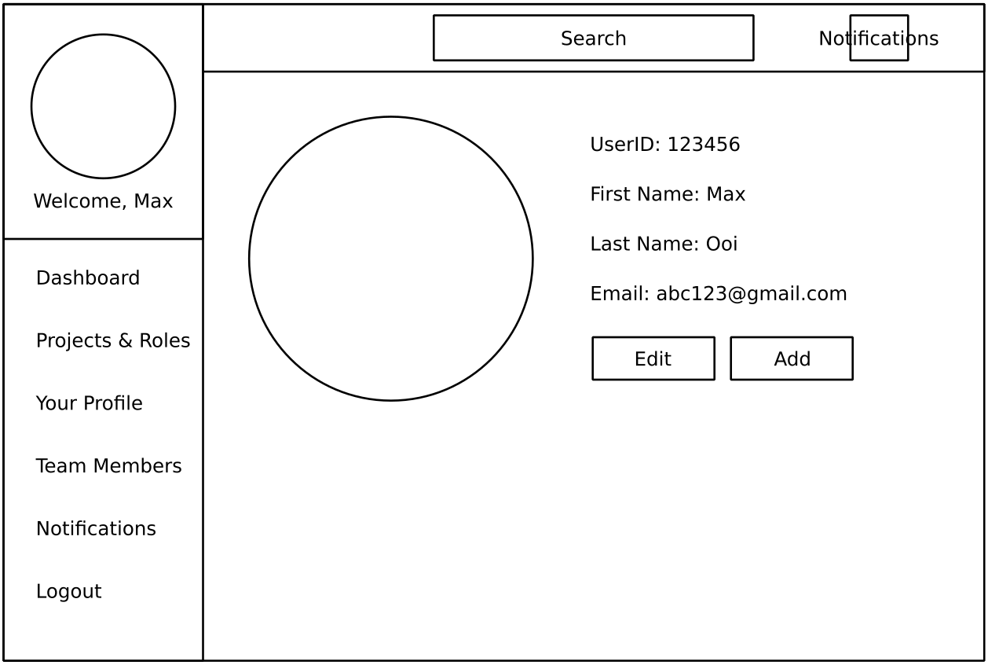

Team Members view
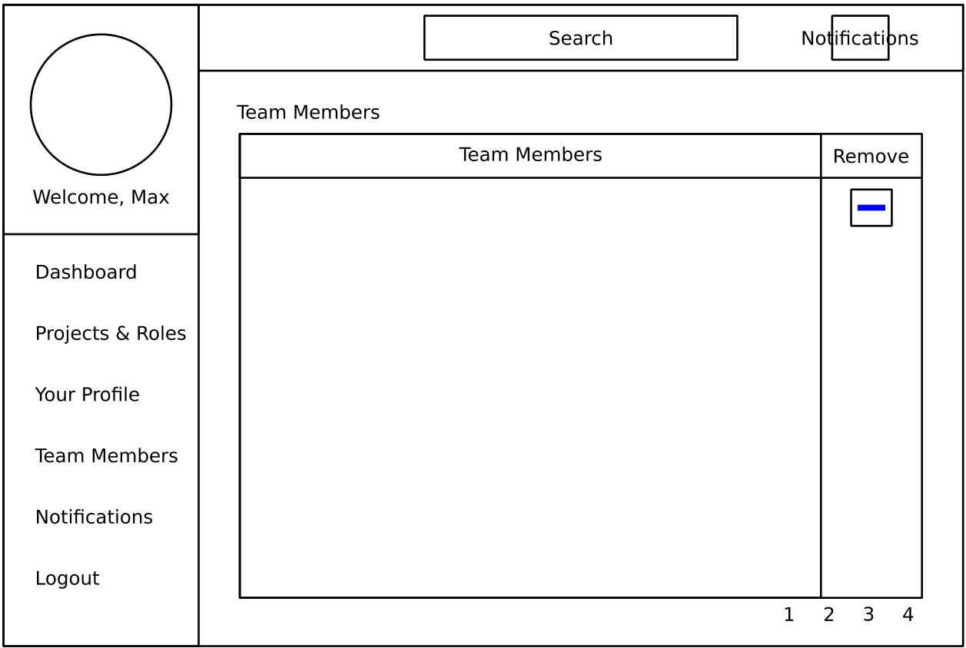

Search Results
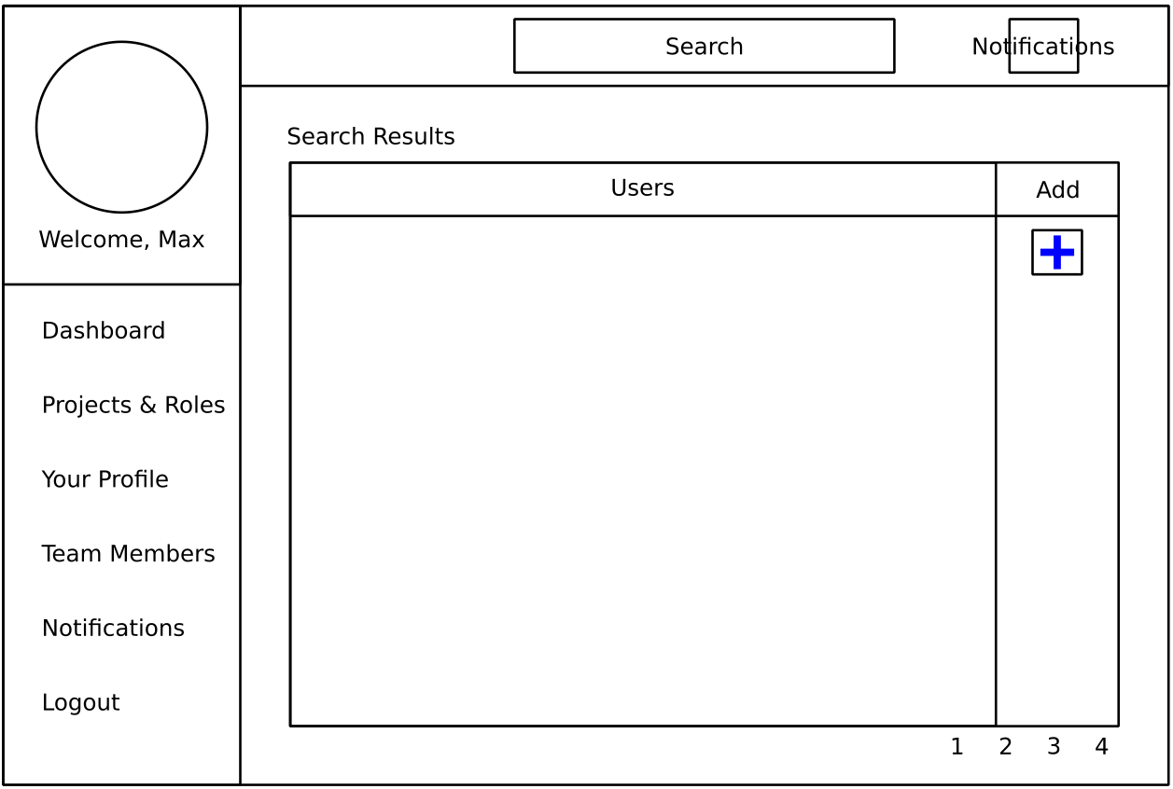

Single Project view
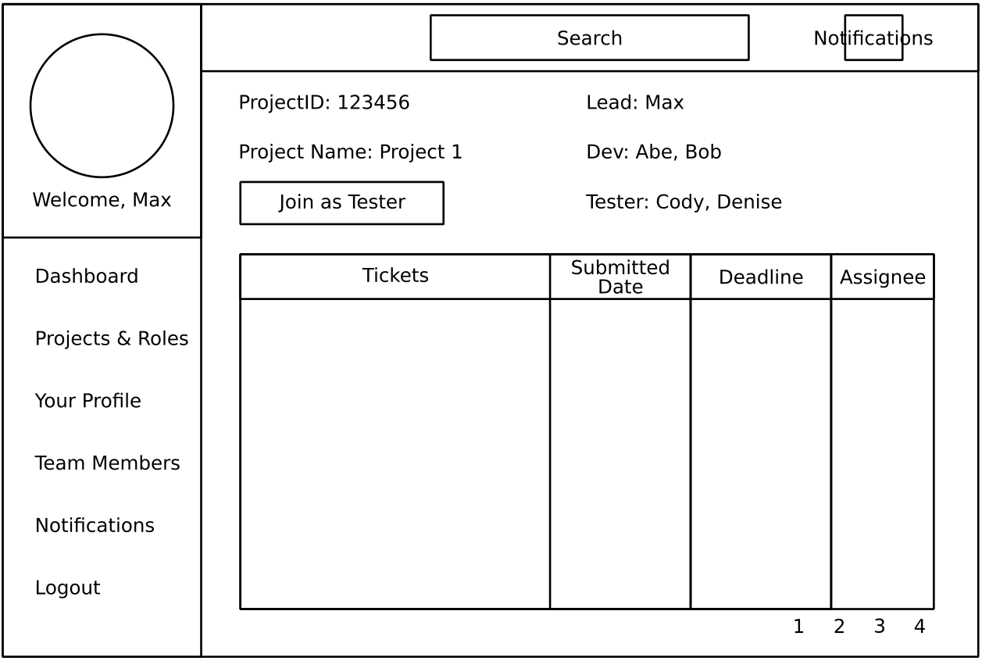

Ticket
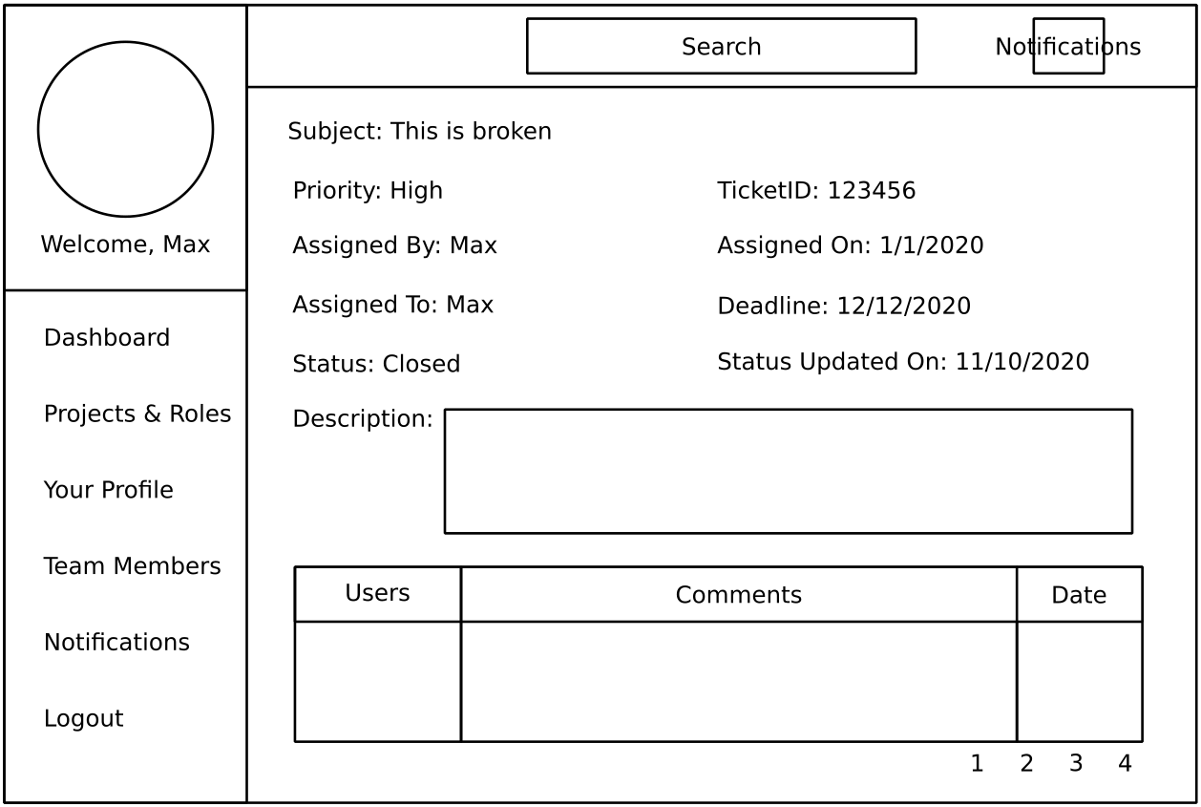

Notifications
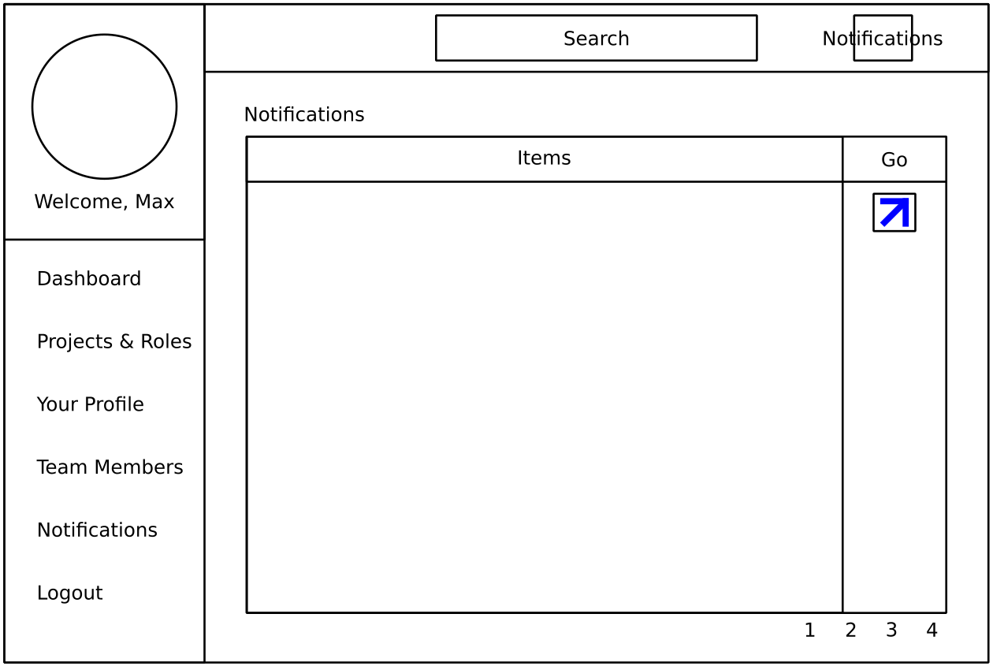

Database Design
Preliminary database design is as below:
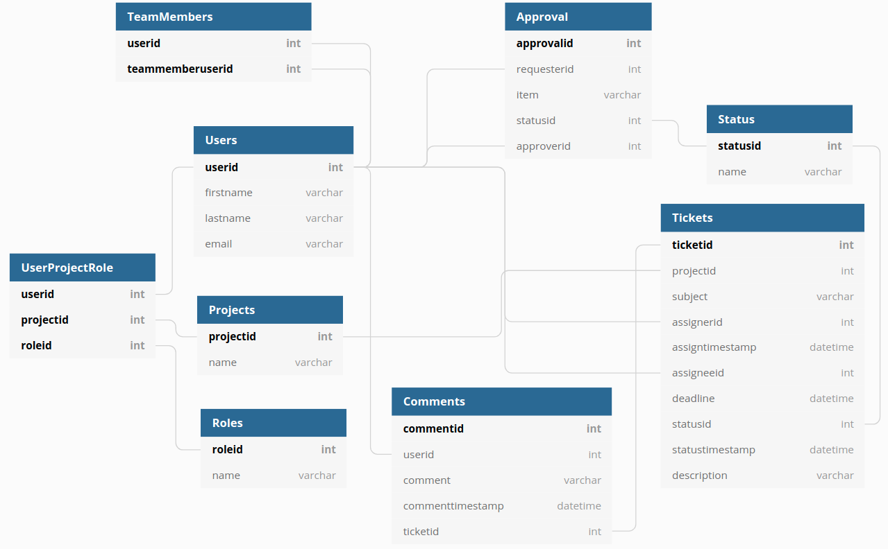

Milestones and Timeline

Month | Sept |  |  |  |  | Oct
Day | 1 | 8 | 15 | 22 | 29 | 6 | 13 | 20 | 27
Items
Authentication and Authorization | x
Data Model |  | x
Projects & Roles, TeamMember UI |  |  | x
Ticket UIs |  |  |  | x
Break |  |  |  |  | x
Dashboard UI |  |  |  |  |  | x
Notifications |  |  |  |  |  |  | x
Bug fixes, deployment and buffer |  |  |  |  |  |  |  | x | x

